**SOP FOR**

**1.0 Purpose : -** Safe Maintenance of TESP

2.0 **Scope**: Sinter plant.

3.0 **Responsibility** : Supervisor, Area in charge, HOD.

4.0 **Procedure** : **MAINTENANCE OF TESP**

***Identified Hazards:***

|  |  |  |
| --- | --- | --- |
| **Energy Sources** | **Potential hazards** | **Consequences** |
| Electrical | * Electrical & Instrumentation cables * Motors | * Electrocution * Burn injuries * Entanglement with rotating motor shafts |
| Kinetic | * Rotating Motor coupling * Rotating hammers | * Trip over pipeline * Entanglement with rotating machine. |
| Mechanical | * Rotating hammers * Rotting Impeller * Linkages | * Entanglement with rotating machine * Entanglement with linkages |
| Potential | * Water on the floor * All steady structures * Electrical & Instrumentation cables * Lubrication lines | * Slip & trip while walking * Trip & fall over cables Or water line laid on floor * Electrocution |
| Thermal | * Overheated motors ,bearings * Heat from electrical cables * Heat from the main duct * Heated electrodes | * Burn Injuries |
| Chemical | * Lubricants * Water * Co gas | * Slip & fall * Water borne disease * Suffocation |
| Radiation | * NA |  |
| Biological | * Mosquitoes * Birds | * Birds attack * Mosquito bites |
| Bio mechanical | * Body posture of operator entering the Chambers. | * Body Pains * Fractures * Disabilities |

**FOR MORE DETAILS REFER CENTRALISED CONFINED SPACE ENTRY SOP-VL/IMS/VAB/SP44 Y**

***Human Hazards:***

1. *Non adherence to WI*
2. *Nonuse of PPE*

***DO’S***

1. *Dust generation.*
2. *Inside heat of TESP.*
3. *Use PPE’s.*
4. *Follow SOP.*
5. *Activity to be carried out during day duty hours.*
6. *New work permit to be taken after every 8 hrs.*
7. *For working in night prior approval should be taken from Head Operations*
8. *Unauthorized operation or repair of any equipment is a punishable offence.*
9. *Before putting Entrant (Fitter/welder/Rigger) on job attendant must ensure that Entrant (Fitter/welder/Rigger) should familiar with the operation.*
10. *Before entering into TESP ensure that shutdown of Tail Fan is taken.*
11. *Before entering into TESP ensure about non availability of CO presence.*
12. *Check the grizzly platform condition (made of rods) for its looseness, to avoid falling of person.*

***DONT’S***

1. *Do not by pass SOP.*
2. *Don’t enter in HESP in presence of CO.*
3. *Don’t enter in HESP if temp is high.*

*Work No 1  :  Inspection of electrodes (Cathode & anode)**plates of TESP.*

*Work No 2 : Inspection / replacement of rapping hammers.*

*Work No 3 : Replacement of electrodes (Cathode) of TESP.*

*Work no 4 : Replacement of slide gate.*

*Work no 5 : Replacement of RAV.*

***Work No 1  :  Inspection of electrodes (Cathode & anode) plates of TESP.***

1. *Before Entering in TESP ensure –*
2. *Take electrical shutdown of Tail fan, transformers, rappers and heaters of TESP.*
3. *TESP inside temperature should be less than 45 degree Celsius.*
4. *CO Level should be 0 ppm*
5. *Attendant must ensure proper illumination, if illumination not found ok, he must inform concern electrical person to provide hand lamp/Torch (24v).*
6. *Take the work permit from HOD, Safety for entering inside TESP.*
7. *The workmen (Entrant) who is trained and certified by SUB head and having valid confined space gate pass should perform the activity and he can be replaced(in emergency) only by certified entrant .*
8. *A standby (attendant) who is trained and certified by SUB head and having valid confined space gate pass should perform the activity and he can be replaced(in emergency) only by certified attendant .*
9. *Standby person who shall be positioned outside the confined space , must have no other duties other than monitoring people and conditions inside the confined space and coordinating with rescue personnel (he must have contact number of rescue team members) if required.*
10. *Standby (Attendant) person has to log down the entry details of all Entrants.*
11. *Check of Internal atmosphere of the space for sufficient oxygen content (19.5% to 23 %) flammable gases and vapors, and the potential for toxic air contaminants before entering into main flue duct. If there is any deviation please do not enter into main flue duct.*
12. *Check for the presence of Chemical asphyxiates such as Carbon monoxide (CO gas detector).It should be 0 PPM*
13. *Check inside temperature and it should be is in the tolerable range (25 deg C to 45 Deg C). If the temperature is not within limits then appropriate ventilation to be used.*
14. *Check for suitability of equipment that is used at the confined space.*
15. *Check any dust due to which visibility is reduced or respiratory tract is irritated.*
16. *The sign-in and sign-out of all persons entering into HESP should be recorded.*
17. *Use 24V DC supply illumination to avoid electrocution/electric shock.*
18. *Ensure that main fan damper is in open condition for natural draft during inspection.*
19. *If everything is OK, enter into TESP and start Inspection of TESP cathode, anode, rapper hammers and dust in hoppers.*
20. *Check all bolts and nuts are properly tightened and tack welded wherever required.*
21. *All Manhole doors & Insulator housing covers are provided with gaskets and are leak proof when closed.*
22. *Alignment of the plates to be checked. Straightness, Gap between anode and cathode (gap to be specified & same has to be checked at 3 different point), Shock bar is in line with the hammers.*
23. *Deviation up to 2mm Bilateral is allowed in gap between anode & cathode from the desired value.*
24. *Anode plates shall be checked for missing items, loose bolts, damages, wear and tear.*
25. *Check for any damage to collecting electrodes, warping due to localized heating, tearing near bolted connections.*
26. *Check for any bent shock bars*
27. *Check for damaged / loose shock pad*
28. *Shock bars are freely moving. Shock bars and link bars are aligned correctly.*
29. *Ensure that the cathode plates are not having any contact with the structure.*
30. *Ensure that the sharp edges are in right position for effective corner discharge.*
31. *Close all inspection doors with proper gasket and lock the gate.*
32. *Normalize the system and release all equipment shutdowns and close the work permit.*
33. *Give the clearance to HOD, SS from your side that your assigned job is completed.*

***Work No 2 : Inspection / replacement of rapping hammers.***

1. *Follow the confined space procedure as shown in above work no1.*
2. *Check for wear and tear of rapping shaft especially where support bearings are located.*
3. *Replace hammer /shaft if required. All bolts and nuts are properly tightened and tack welded wherever required.*
4. *Hammers and discharge plates are aligned correctly.*
5. *Ensure all the tools & tackles are removed out.*
6. *Close all inspection doors with proper gasket and lock the gate.*
7. *Normalize the system and release all equipment shutdowns and close the work permit.*
8. *Give the clearance to HOD, SS from your side that your assigned job is completed.*

***Work No 3: Replacement of electrodes (Cathode) of TESP.***

1. *Follow the confined space procedure as shown in above work no1.*
2. *Ensure emptying of all six bunkers before water washing*
3. *Before carry out the job ensure gas cutting set/welding machine should be certified.*
4. *Cut and removed the old electrode by gas cut.*
5. *Fix the new electrode and bolted properly by torque wrench and welded it.*
6. *Use safety belt while replacing top side cathode.*
7. *Ensure all the tools & tackles are removed out.*
8. *Close all inspection doors with proper gasket and lock the gate.*
9. *Normalize the system and release all equipment shutdowns and close the work permit.*
10. *Give the clearance to HOD, SS from your side that your assigned job is completed.*

***Work no 4 : Replacement of slide gate.***

1. *Ensure that the hopper is empty before starting the job.*
2. *Take electrical shutdown of main fan and deducting system.*
3. *Take work permit from SS production department.*
4. *Remove the slide gate out and remove the flange bolts.*
5. *Position the new slide gate and tighten the flange bolts.*
6. *Normalize the system and release all equipment shutdowns and close the work permit.*
7. *Give the clearance to HOD, SS from your side that your assigned job is completed.*

***Work no 5 : Replacement of RAV.***

1. *Ensure that the hopper is empty and slide gate should be closed fully before starting the job.*
2. *Take electrical shutdown of deducting system.*
3. *Take work permit from SS production department.*
4. *Get the RAV motor connection removed by the electrical department.*
5. *Remove the flange bolts of the RAV and pull it out with the help of chain block.*
6. *Position the new RAV with the help of chain block.*
7. *Tighten the flange bolts.*
8. *Get the electrical connection of the RAV motor: done by electrical.*
9. *Normalize the system and release all equipment shutdowns and close the work permit.*
10. *Give the clearance to HOD, SS from your side that your assigned job is completed.*

*Please note that this area is considered as Confined Space so needs to maintain the checklist of the activity. All in time and out time details of entrants, levels of gases to be logged in checklist (yellow copy) or in any alternate document and to be documented.*

***Role of Rescue Team***

***As the work is being carried out inside HESP, in an emergency victim can be taken out by use of rescue apparatus such as stretcher. However attendant should call ambulance which is fully equipped. However rescue team members should take a charge of the situation.***

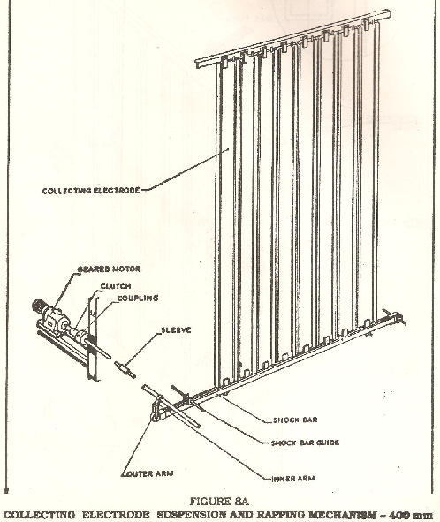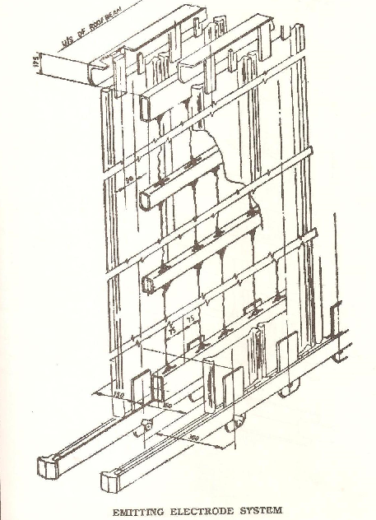

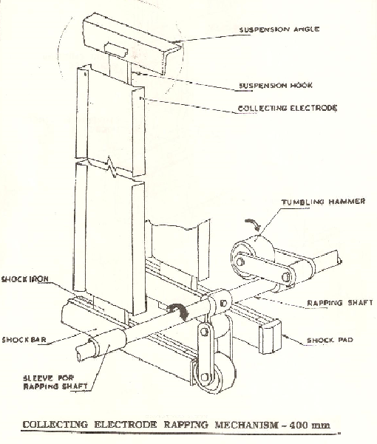

**Reference: - (Confines Space-VAB/PIEP/43)**

**Amendement Record**

|  |  |  |  |
| --- | --- | --- | --- |
| **Date** | **Manual Section Ref. & Para** | **Brief details of Revision** | **New Rev.** |
|  |  |  |  |
|  |  |  |  |
|  |  |  |  |

|  |  |  |
| --- | --- | --- |
| **Prepared By:**  Associate Manager- Sinter Plant Mechanical | **Reviewed & Issued By:**  Management Representative | **Approved By:**  **Manager- Mechanical PID2** |
| **Signature:** | **Signature:** | **Signature:** |
| **Review Date: 14.07.2022** | **Review Date: 14.07.2022** | **Review Date: 14.07.2022** |